COLLEGE OF ARTS AND SCIENCES

Department of Biology, MSC 3AF

New Mexico State University

P.O. Box 30001

Las Cruces, NM 88003-8001

Telephone: (575) 646-3611

Fax: (575) 646-5665



XX July 2023

 Dear Editors,

My coauthors and I are pleased to submit our manuscript entitled ‘A cultural atlas of vocal variation: yellow-naped amazon contact calls exhibit discreet call types throughout their range’ for your consideration as an original research article for the special issue ‘Cryptic Diversity Within Bird Species Revealed by Call Types’ in *Frontiers in Bird Science*. Vocal dialects have been described in a wide range of avian species, but only rarely has variation in learned vocalizations been examined across the entire range of a species. Thus it is difficult to infer whether dialect formation is intrinsic to a species or dependent of local social and ecological processes that may vary spatially.

To address this question, we examined acoustic variation in contact calls across the Mesoamerican range of the yellow-naped amazon, a parrot species in which vocal dialects have been previously described in Costa Rica populations. We used multiple analytical approaches to confirm that the mosaic pattern of variation seen in Costa Rica is present across the entire range of this species. Calls could be classified into discreet types that were regionally specific. Although no specific call types were repeated across the range, similar structural characteristics could be detected in multiple call types, suggesting conserved paths of cultural evolution. These results support the idea that dialect formation is a general product of social dynamics that favor philopatry and the matching of local call types in this species. We feel our paper fits the goal of the special issue to document call diversity in a wide range of avian taxa.

We suggest as editors Thomas Hahn and Matthew Young. As reviewers, we suggest the following:

* Jeff Podos, Department of Biology, University of Massachusetts: jpodos@umass.edu
* Karl Berg, Department of Biology, University of Texas Rio Grande Valley: karl.berg@utrgv.edu
* Any suggestions of reviewers outside the US who work on vocal variation??

For review purposes, we have provided links to a GitHub site that contains all of our code, and a Dryad site that hosts our primary data. We thank you for your consideration of this study and look forward to your decision on our manuscript.

Sincerely,

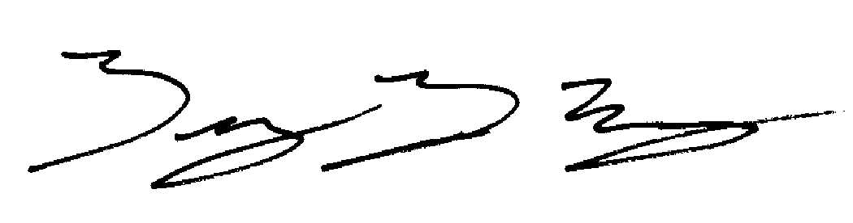

Timothy F. Wright

Professor of Biology